Local Flask Endpoint for ML Model

Create All Scripts in Root Project Folder
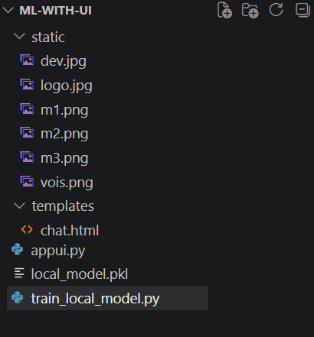

Step 1 - Install Flask
pip install flask joblib pandas scikit-learn
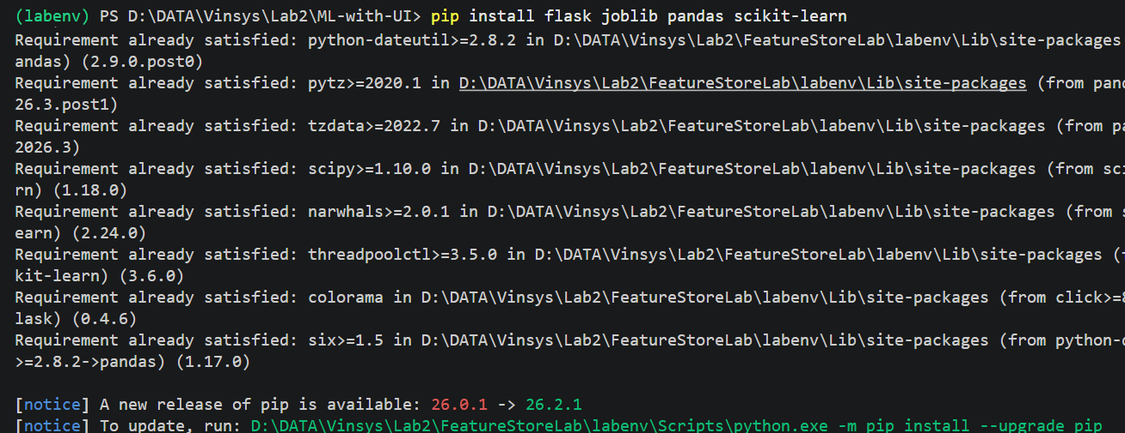

Step 2 - Train and Save Model (quick demo)
train_local_model.py

import pandas as pd
from sklearn.tree import DecisionTreeClassifier
import joblib

# Tiny dataset
df = pd.DataFrame({
"MonthlyDataUsage":[10,6,15,8],
"AverageCallCount":[120,90,160,110],
"MonthlyBill":[800,450,1200,650],
"UsageBillingRatio":[0.012,0.013,0.012,0.012],
"BillingStatus":[0,0,1,0]
})

X = df[["MonthlyDataUsage","AverageCallCount","MonthlyBill","UsageBillingRatio"]]
y = df["BillingStatus"]

model = DecisionTreeClassifier(random_state=42)
model.fit(X, y)

joblib.dump(model, "local_model.pkl")
print("Model saved as local_model.pkl")

Run once:
py train_local_model.py

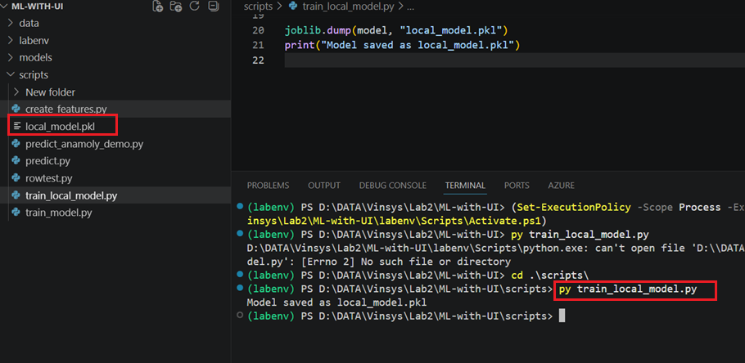

Step 3 - Create Local Endpoint
appui.py
# app.py for endPoint
from flask import Flask, render_template, request, jsonify
import joblib
import pandas as pd

app = Flask(__name__)
model = joblib.load("local_model.pkl")

@app.route("/")
def index():
return render_template("chat.html")

@app.route("/predict", methods=["POST"])
def predict():
data = request.get_json()
df = pd.DataFrame([data])
prediction = model.predict(df)[0]
result = "Normal Billing" if prediction == 0 else "Billing Anomaly Detected"
return jsonify({"response": result})

if __name__ == "__main__":
app.run(port=5000, debug=True)

Step 4- Frontend (HTML + JS)
Save this as templates/chat.html:

<!DOCTYPE html>
<html>
<head>
<title>Vodafone Billing Predictor</title>
<style>
body { margin:0; font-family:Arial, sans-serif; background:#f9f9f9; }
header { background:#e60000; color:#fff; padding:15px; font-size:20px; font-weight:bold; display:flex; align-items:center; }
header img { height:40px; margin-right:10px; }

.container { display:flex; height:calc(100vh - 50px); }

/* Sidebar */
.sidebar {
width:220px; background:#fff; border-right:1px solid #ddd; padding:20px;
display:flex; flex-direction:column; justify-content:space-between;
}
.sidebar h3 { color:#e60000; margin-bottom:20px; }
.sidebar a { display:block; padding:10px; margin-bottom:10px; color:#333; text-decoration:none; border-radius:4px; }
.sidebar a:hover { background:#e60000; color:#fff; }
.developer {
font-size:12px; color:#e60000; margin-top:20px; font-weight:bold;
}

/* Main content */
.main { flex:1; padding:30px; background:#fff; overflow-y:auto; }
.main h2 { color:#e60000; }
.card { background:#f2f2f2; padding:20px; border-radius:8px; margin-bottom:20px; text-align:center; }

/* Restrict image size */
.card img {
max-width:80%; /* keep images neat */
height:auto;
border-radius:8px;
}

/* Right panel */
.right { width:350px; background:#fff; padding:20px; border-left:1px solid #ddd; }
.right h3 { color:#e60000; }
.right input, .right button { width:100%; padding:10px; margin:10px 0; border:1px solid #ccc; border-radius:4px; }
.right button { background:#e60000; color:#fff; cursor:pointer; }
.right button:hover { background:#b30000; }

#predictionResult { margin-top:20px; text-align:center; font-size:48px; font-weight:bold; color:#e60000; }

footer { background:#e60000; color:#fff; text-align:center; padding:10px; position:absolute; bottom:0; width:100%; }

/* Robot mascot fixed bottom-right */
#robotImage { position:fixed; bottom:20px; right:20px; width:150px; }
</style>
</head>
<body>
<!-- Header with logo -->
<header>
<img src="{{ url_for('static', filename='logo.jpg') }}" alt="VOIS Logo">
Vodafone Billing Predictor
</header>

<div class="container">
<!-- Sidebar -->
<div class="sidebar">
<div>
<h3>Menu</h3>
<a href="#">Dashboard</a>
<a href="#">Predict Bill</a>
<a href="#">Usage Insights</a>
<a href="#">Bill History</a>
<a href="#">Plan & Offers</a>
<a href="#">Alerts & Reminders</a>
<a href="#">Settings</a>
</div>
<!-- Developer credit -->
<!-- Developer credit with image -->
<div class="developer">
<p style="color:#e60000; font-weight:bold; text-align:center; font-size:15px; background:#fff; padding:5px; border-radius:4px;">
Developed By: Bipeen Sinha<br>
VOIS Team
</p>
<img src="{{ url_for('static', filename='dev.jpg') }}"
alt="Developer"
style="width:100%; border-radius:8px; margin-bottom:10px;">

<!-- Strong visible text -->
<p style="color:#e60000; font-weight:bold; text-align:center; font-size:15px; background:#fff; padding:5px; border-radius:4px;">
Developed By: Bipeen Sinha<br>
VOIS Team
</p>
</div>

</div>

<!-- Main content -->
<div class="main">
<h2>Predict Tomorrow’s Bill, Today</h2>
<p>
Our AI-powered Billing Prediction App helps customers understand and anticipate their upcoming mobile bills with greater clarity and confidence.
</p>

<!-- Banner / smartphone graphic -->
<div class="card">
<img src="{{ url_for('static', filename='m2.png') }}" alt="Smartphone Graphic">
</div>

<!-- At a Glance -->
<div class="card">
<h3>At a Glance</h3>
<p>Predicted Bill: ₹1,249 Next Month (↓12% vs Last Month)</p>
<p>Data Usage: 18.6 GB (↑8%)</p>
<p>Voice Usage: 320 Mins (↑5%)</p>
<p>SMS Usage: 142 SMS (↑10%)</p>
</div>

<!-- Why Predict Your Bill -->
<div class="card">
<h3>Why Predict Your Bill?</h3>
<ul style="text-align:left;">
<li>Stay informed and avoid unexpected charges</li>
<li>Track usage trends and control spending</li>
<li>Get personalized plan recommendations</li>
<li>Make smarter choices every month</li>
</ul>
</div>
</div>

<!-- Right panel -->
<div class="right">
<h3>Get Your Billing Status</h3>
<input id="dateRange" placeholder="Select Date Range">
<input id="mobileNumber" placeholder="Mobile Number">
<input id="dataGB" placeholder="Monthly Data Usage (GB)">
<input id="calls" placeholder="Average Call Count">
<input id="bill" placeholder="Monthly Bill (₹)">
<input id="ratio" placeholder="Usage/Bill Ratio">
<button onclick="sendPrediction()">Check Status</button>
<button onclick="clearForm()">Clear</button>

<!-- Result area -->
<div id="predictionResult"></div>
</div>

<footer>
Your data is safe and secure • AI-Powered Predictions • Real-time Usage Analysis • 100% Secure
</footer>

<!-- Robot mascot -->
<img id="robotImage" src="{{ url_for('static', filename='vois.png') }}" alt="Vodafone Robot">

<<script>
function sendPrediction() {
let data = {
MonthlyDataUsage: parseFloat(document.getElementById("dataGB").value),
AverageCallCount: parseFloat(document.getElementById("calls").value),
MonthlyBill: parseFloat(document.getElementById("bill").value),
UsageBillingRatio: parseFloat(document.getElementById("ratio").value)
};

fetch("/predict", {
method: "POST",
headers: {"Content-Type":"application/json"},
body: JSON.stringify(data)
})
.then(res => res.json())
.then(res => {
// Show billing status clearly
document.getElementById("predictionResult").innerText = "Billing Status: " + res.response;

// Optional: color-code result
if (res.response === "Normal Billing") {
document.getElementById("predictionResult").style.color = "green";
} else {
document.getElementById("predictionResult").style.color = "red";
}
});
}

function clearForm() {
document.getElementById("dataGB").value = "";
document.getElementById("calls").value = "";
document.getElementById("bill").value = "";
document.getElementById("ratio").value = "";
document.getElementById("predictionResult").innerText = "";
}
</script>

</body>
</html>

Step 4 – Execute appui.py
appui.py
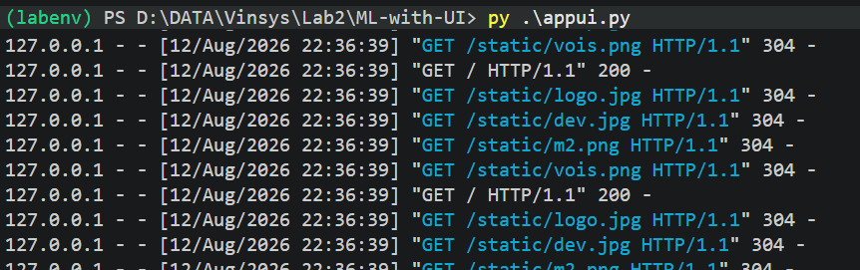

Step 5 – Test with browser
http://127.0.0.1:5000/

